**Math 120  
2.1 Linear Equations and Rational Equations**

# Objectives

1. Solve linear equations in 1 variable.
2. Solve linear equations containing fractions.
3. Recognize identities, conditional equations, and inconsistent equations.
4. Solve rational equations with variables in the denominator.
5. Solve applied problems using linear functions.

# Topic #1: Solving Linear Equations in One Variable – By “Hand”

Linear functions can be written in the form

$f\left(x\right)=mx+b$.

Consider the linear functions $f\left(x\right)=2\left(x-3\right)-17$ and $g\left(x\right)=13-3(x+2)$. Suppose we want to find where $f\left(x\right)=g(x)$. It may not be obvious that the functions are linear, but the resulting equation is: $f\left(x\right)=g(x)$

$2\left(x-3\right)-17=13-3(x+2)$

The result is the solution set to the equation, we can plug into the original equation to verify:

Moreover, the original functions are shown to be equivalent at $x=6$:

Thinking of linear equations as 2 lines provides the basis for the steps to solving a linear equation:

1. Simplify both sides of the equation as much as possible (get both sides in $y=mx+b$ form). Clear __________________________if necessary (LCM).
2. Collect all variable terms to one side of the equation and the constant terms _______________
3. ____________________the variable to solve.
4. Check the proposed solution in the original equation.

*Example #1* – Solve the Linear Equation

a. $3\left(x-2\right)+7=2(x+5)$ b. Suppose $y=5\left[x-\left(2-x\right)\right]-9(x+1)$. **Find the zeros of the equation.**  **In other words, find all $x$ values such that $y=0$.**

$\text{c. }\frac{x}{11}=\frac{x}{12}-3$ $\text{d. }\frac{x+5}{4}=1-\frac{x+6}{9}$

# Topic #2: Solving Linear Equations in One Variable – With Technology

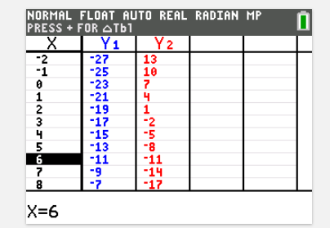We can use a graphing calculator to solve equations.

Recall the equation:

$2\left(x-3\right)-17=13-3(x+2)$

We can input the left side of the equation in the calculator as $y_{1}=2\left(x-3\right)-17$ and the right side of as $y_{2}=13-3(x+2)$

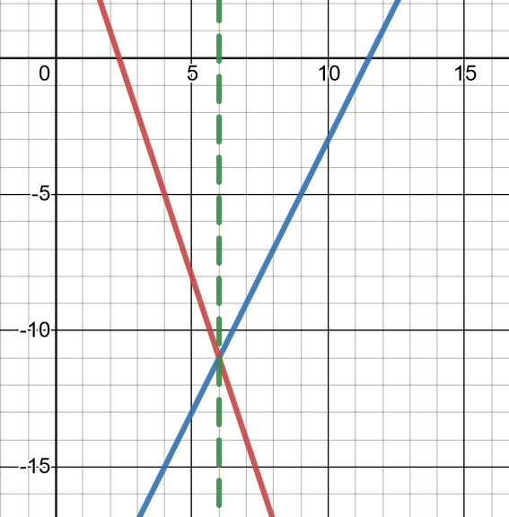Look at a table to see what $x$ values makes them equal (in other words $y_{1}=y_{2})$.

Based on the table below, we can see that both sides are equivalent when ______________________

We can also look at the graph of the two sides of the equation to see where they meet. This point along the x-axis is the solution.

*Example #1* – Use the Table to Write and Solve the Linear Equation

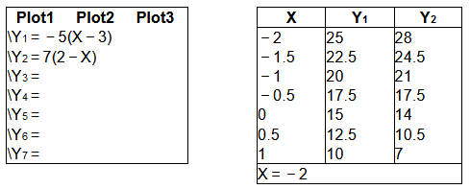

Here $y_{1}=___________________{\text{ and }y}_{2}=__________________$.

The resulting equation is

$y_{1}=y_{2}$ OR $-5\left(x-3\right)=7(2-x)$.

The solution to the equation is at $x=________________$

*Technology is useful, feel free to use it as you see fit!*

# Topic #3: Solution Types to Linear Equations

There are 3 types possible solution sets when solving linear equations:

1) **Conditional** – there is a **_____________** solution set. The equation is only _____________ for certain values.

Recall that the equation:

$2\left(x-3\right)-17=13-3(x+2)$ has a solution when $x=6$.

This equation is **only** true when $x=6$, so the equation is **_____________________**

2) **Identity** – there is an **______________** solution set. The equation is always true and x is a real number.

Consider the equation: $6x+2=2(3x+1)$

Which simplifies to:

Collecting the variable terms and constant terms to either side gives

This equation is **always** true, so the equation is an **____________________**

3) **Inconsistent** – there is **_______________** solution. The equation is **_______________** true, which we can convey with the null symbol:

Consider the equation: $6x+2=2(3x+2)$

Which simplifies to:

Collecting the variable terms and constant terms to either side gives:

This is **never** true, so the equation is **____________________**

*Example #1* – Solve the Linear Equation and Categorize the Solution Type

a. $3\left(x+2\right)=7+3x$ b. $5x+9=9\left(x+1\right)-4x$

c. $10x+3=8x+3$

***YOU TRY #1* –** Solve the Linear Equation and Categorize the Solution Type

**a.  b. **

**c. ** **d. **

# Topic #4: Solving Rational Equations

Rational equations include a variable in the denominator.

Since division by zero is _____________, we cannot accept any solution that makes the denominator ___________.

We clear out denominators with the _______________________________

From there, the equation will become “linear” – we just have to make sure none of the solutions make the denominator zero. Otherwise, we throw it out of the solution set.

Consider the equation:

$\frac{1}{x}=\frac{1}{5}+\frac{3}{2x}$ What is the restricted value?

1. Identify the LCM.

The unique factors are ________________________ (the factor $x$ shows up twice, but is only unique once), which gives an LCM of _______________

2. Multiply each term by the LCM ______________ to clear out the denominators:

3. This simplifies to a linear equation:

4. Solve the equation with techniques discussed earlier and check the restricted values:

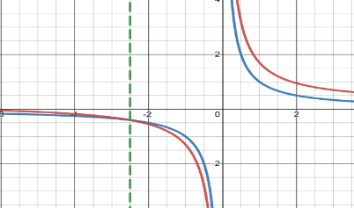

Since this is not the excluded value $x≠0$, the solution works.

A graph also confirms the solution, where:

$$y_{1}=_______________ \text{and }y_{2}=___________________$$

Notice the two sides meet when x = ____________

*Example #1* – State the Excluded Values and Solve the Rational Equation

1. Identify restricted values:

2. Identify LCM 3. Multiply every term by LCM

4. Simplify to linear equation. 5. Solve and check the restricted values.

1. Identify restricted values:

2. Identify LCM 3. Multiply every term by LCM

4. Simplify to linear equation. 5. Solve and check the restricted values.

1. Identify restricted values:

2. Identify LCM 3. Multiply every term by LCM

4. Simplify to linear equation. 5. Solve and check the restricted values.

A table generated by a graphing calculator can also solve the equation (notice the parenthesis), where:

$$y_{1}=\frac{2}{x+1}-\frac{1}{x-1}\text{AND} y_{2}=\frac{2x}{x^{2}-1}$$

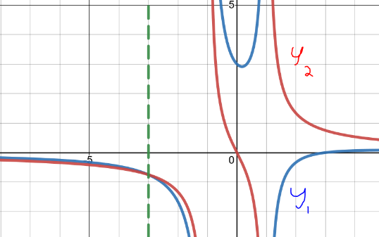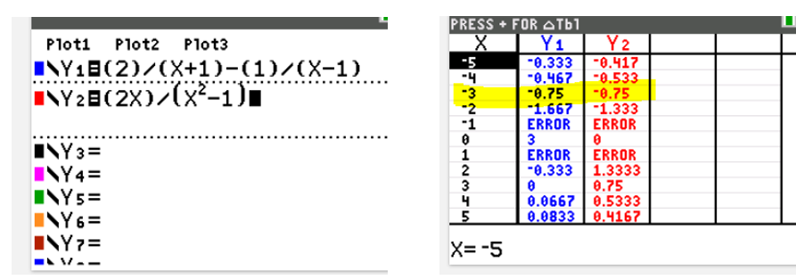

A graph also works!

*YOU TRY #2* – Solve the following equations. Make sure to include any restricted values if there are any.

**a.  b. **

# Topic #5: Applications of Linear and Rational Equations

Linear and rational equations are often are used to model data.

*Example #1* – Application of a Linear Equation

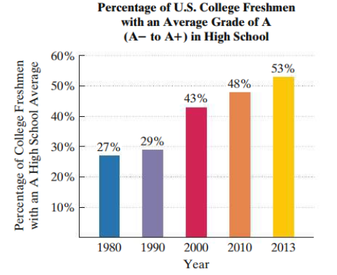The bar graph shows the percentage of US college freshmen with an average grade of A in high school over time.

One model for the data is given by the equation:

$$p-\frac{4x}{5}=25$$

Where $p$ is the percentage with an average grade of A and $x$ are years after 1980.

Let x be:

Let P be:

a. According to the model, what percentage of US college freshmen have an average grade of A in 2010? How far off is the model from the actual data?

2010 is 30 years after 1980, which gives x = ______

b. Based on the model, when will the percentage of US college freshmen with an average grade of A be 61%?

The projected percentage is given, $p=61$. Plug into the equation and solve for $x$, which is the number of years after 1980:

*Example #2* – Application of a Rational Equation

A learning curve is a math model that estimates the proportion of correct responses on a test/task in terms of the number of trials/attempts. As the number of trials/attempts increase, the proportion of correct responses increase.

Consider the model

$$P\left(x\right)=\frac{0.9x-0.4}{0.9x+0.1}$$

where $P$ is the proportion correct and $x$ is the number of trials.

Let x be:

Let P(x) be:

a. Find $P\left(1\right)$ and interpet its meaning.

b. How many trials are necessary to get 95% correct responses?